Managing Covid-19 reporting and testing at East Sussex College, 18 January 2022

Today’s update includes:
- a reminder for all education and childcare settings about the changes to the self-isolation period for those who test positive for COVID-19, from Monday 17 January

Changes to the self-isolation period for those who test positive for COVID-19
This change came into effect in England on Monday 17 January and applies to all positive cases, regardless of vaccination status.
People who are self-isolating with COVID-19 have the option to reduce their isolation period after 5 full days if they test negative with an LFD test on both day 5 and day 6 and they do not have a temperature. For example, if they test negative on the morning of day 5 and the morning of day 6, they can return to their education or childcare setting immediately on day 6.
The first test must be taken no earlier than day 5 of the self-isolation period, and the second must be taken the following day. All test results should be reported to NHS Test and Trace.
If the result of either test is positive, they should continue to self-isolate until they get negative results from two LFD tests on consecutive days or until they have completed 10 full days of self-isolation, whichever is earliest.
The new rules also apply to people who are already isolating – so if someone was already isolating before Monday 17 January, they can take LFD tests on day 5 and 6 and if they are both negative and they have no temperature they can end their isolation.
Anyone who is unable to take LFD tests or anyone who continues to have a temperature will need to complete the full 10-day period of self-isolation.
Further information on self-isolation for those with COVID-19 is available.

Introduction/Overview

The Government continues to manage the risk of serious illness from the spread of the virus. The Prime Minister announced on 27 November the temporary introduction of new measures as a result of the Omicron variant and on 8 December that Plan B, set out in the autumn and winter plan 2021, was being enacted. As a result, these measures are reflected in this guidance document. This advice remains subject to change as the situation develops.
Our priority is for us to deliver face-to-face, high-quality education to all pupils. The evidence is clear that being out of education causes significant harm to educational attainment, life chances, mental and physical health.
We have worked closely with the Department of Health and Social Care (DHSC) and (UKHSA) to revise this guidance.

Mixing and ‘bubbles’
We do not recommend that it is necessary to keep students in consistent groups (‘bubbles’).

Tracing close contacts and isolation

Close contacts will be identified via NHS Test and Trace and Education settings are not expected to undertake contact tracing.
From 14 December 2021, adults who are fully vaccinated and all children and young people aged between 5 and 18.5 years identified as a contact of someone with COVID-19 are strongly advised to take a LFD test every day for 7 days and continue to attend their setting as normal, unless they have a positive test result. Daily testing of close contacts applies to all contacts who are:
• fully vaccinated adults – people who have had 2 doses of an approved vaccine
• all children and young people aged 5 to 18.5 years, regardless of their vaccination status
• people who can prove they are not able to get vaccinated for medical reasons
• people taking part, or have taken part, in an approved clinical trial for a COVID-19 vaccine.

Students with SEND identified as close contacts should be supported by their setting and their families to agree the most appropriate route for testing including, where appropriate, additional support to assist swabbing. For further information please see SEND guidance.
18-year-olds are treated in the same way as children until 6 months after their 18th birthday, to allow them the opportunity to get fully vaccinated. At this point, they will be subject to the same rules as adults and so if they choose not to get vaccinated, they will also need to self-isolate if identified as a close contact.

Face coverings
From 4 January we recommend that face coverings should be worn by staff and students when moving around the premises, in corridors and communal areas and in classrooms or workshops.
This does not apply in situations where wearing a face covering would impact on the ability to take part in exercise or strenuous activity, for example during sports lessons and physical activity.
Face coverings do not need to be worn by staff or students when outdoors on the premises.
We would not ordinarily expect teachers to wear a face covering whilst teaching students if they are at the front of the class, to support education delivery, although settings should be sensitive to the needs of individual teachers.
The recommendation to wear face coverings in classrooms and other teaching areas such as workshops will be introduced for a limited time, and as with all measures, we will keep it under review and update guidance after that point. Face coverings protect the wearer and others against the spread of infection because they cover the nose and mouth, which are the main confirmed sources of transmission of COVID-19.
No student should be denied education on the grounds that they are not wearing a face covering.

Access to face coverings

Due to the use of face coverings in wider society, staff and students are already likely to have access to face coverings.
We have a small contingency supply available at each Campus reception desks for people who:
• are struggling to access a face covering.
• are unable to use their face covering as it has become damp, soiled, or unsafe
• have forgotten their face covering Staff and students may consider bringing a spare face covering to wear if their face covering becomes damp during the day.

Asymptomatic Testing

Testing remains important in reducing the risk of transmission within settings

Control measures
You should:
1. Ensure good hygiene for everyone.
2. Maintain appropriate cleaning regimes.
3. Keep occupied spaces well ventilated.
4. Follow public health advice on testing, self-isolation and managing confirmed cases of COVID-19.

1. Ensure good hygiene for everyone

Hand hygiene
Frequent and thorough hand cleaning should now be regular practice. You should continue to ensure that students clean their hands regularly. This can be done with soap and water or hand sanitiser.
Respiratory hygiene
The ‘catch it, bin it, kill it’ approach continues to be very important.

2. Maintain appropriate cleaning regimes using standard products such as detergents

We have put in place and maintained an appropriate cleaning schedule. This includes regular cleaning of areas and equipment, with a particular focus on frequently touched surfaces.
We have cleaning operatives who carry this out throughout the day.

3. Keep occupied spaces well ventilated

It is important to ensure the college is well ventilated and that a comfortable teaching environment is maintained.
Please keep widows open and where we have mechanical ventilation, these should be set to draw in fresh air to support a safe environment rather than “recirculation” mode.
Opening external windows can improve natural ventilation, and in addition, opening internal doors can also assist with creating a throughput of air. If necessary external opening doors may also be used (if they are not fire doors and where safe to do so).
We currently monitor various teaching spaces throughout the college to ensure CO2 levels, temperature and humidity levels are safe with the use of government supplied monitors.

4. Follow public health advice on testing, self-isolation and managing confirmed cases of COVID-19

When an individual develops COVID-19 symptoms or has a positive test

Students, staff, and other adults should follow public health advice on when to self-isolate. They should not come into the setting if they have symptoms or other reasons requiring them to stay at home due to the risk of them passing on COVID-19 (for example, they are required to quarantine).
Staff and students should not visit the college if they have any of the symptoms i.e.
- A high temperature
- A new, continuous cough
- Loss or change to your sense of smell or taste

If anyone within the college develops COVID-19 symptoms, however mild, you should send them home and they should follow public health advice.
For everyone with symptoms, they should avoid using public transport and, wherever possible, be collected by a member of their family or household.

Reporting

Staff and students will be asked to report that they have symptoms or have tested positive for Covid-19 to the college via the form available on our website.

Student Reporting Form | East Sussex College (escg.ac.uk)

Staff Reporting Form | East Sussex College (escg.ac.uk)

Stay at home and self-isolate
Stay at home and self-isolate if you have any of the main symptoms of COVID-19 or if you have a positive LFD or PCR test result. Self-isolation will help protect your family, friends, and the wider community by reducing the risk that you will pass the infection on to others.
Your self-isolation period starts immediately from when your symptoms started, or, if you do not have any symptoms, from when your positive LFD or PCR test was taken, whichever test was taken first. Your self-isolation period includes the day your symptoms started (or the day your test was taken if you do not have symptoms), and the next 10 full days. It may be possible to end your self-isolation earlier (see below).
This means that if, for example, your symptoms started at any time on the 15th of the month (or if you did not have symptoms but your first positive COVID-19 test was taken on the 15th), your self-isolation period ends at 23:59hrs on the 25th of the month.
You can return to your normal routine and stop self-isolating after 10 full days if your symptoms have gone, or if the only symptoms you have are a cough or anosmia, which can last for several weeks. If you still have a high temperature after 10 days or are otherwise unwell, stay at home and seek medical advice.
You may be able to end your self-isolation period before the end of the 10 full days. You can take an LFD test from 6 days after the day your symptoms started (or the day your test was taken if you did not have symptoms), and another LFD test on the following day. The second LFD test should be taken at least 24 hours later. If both these test results are negative, and you do not have a high temperature, you may end your self-isolation after the second negative test result.
Report your LFD test results after taking each test.
You should not take an LFD test before the sixth day of your self-isolation period, and you should only end your self-isolation after you have had 2 consecutive negative LFD tests which should be taken at least 24 hours apart. You should stop testing after you have had 2 consecutive negative test results.
You will be unable to use either your domestic or travel NHS COVID Pass for 10 days following a positive test result.

Examples of when to end self-isolation if you have had COVID-19 symptoms or have received a positive COVID-19 test result
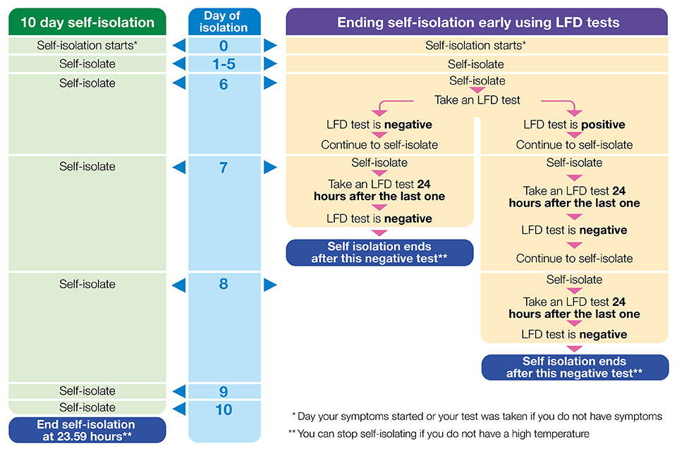
This means that if, for example, your symptoms started at any time on the 15th of the month (or if you did not have symptoms but your first positive COVID-19 test was taken on the 15th), you may take daily LFD tests from the 21st of the month. If your LFD test results are negative on the 21st and 22nd, and you do not have a high temperature, you may end your self-isolation period after the negative test result on the 22nd of the month.
If both your LFD test results are negative, it is likely that you were not infectious at the time the tests were taken. To further reduce the chance of passing COVID-19 on to others, if you end your self-isolation period before 10 full days you are strongly advised:
- to limit close contact with other people outside your household, especially in crowded, enclosed or poorly ventilated spaces
- to work from home if you are able to
- in addition to venues where it is a legal requirement, to wear a face covering in crowded, enclosed or poorly ventilated spaces and where you are in close contact with other people
- to limit contact with anyone who is at higher risk of severe illness if infected with COVID-19
You should follow this advice until 10 full days from when your self-isolation period started.
You do not need to take any more LFD tests after the 10th day of your self-isolation period, and you may stop self-isolating after this day. This is because you are unlikely to be infectious after the 10th day of your self-isolation period. Even if you have a positive LFD test result on the 10th day of your self-isolation period you do not need to take any more LFD tests after this day and you do not need a follow-up PCR test. If you are concerned you may choose to limit close contact with other people, especially those who are at higher risk of severe illness until 14 days after the start of your self-isolation period.
If you are self-isolating because of a positive test result but did not have any symptoms, and you develop COVID-19 symptoms within your self-isolation period, you do not need to start a new self-isolation period.
If you develop COVID-19 symptoms at any point after ending your first period of self-isolation you and your household should follow the steps in this guidance again.
Most people with COVID-19 will experience a mild illness. Seek prompt medical attention if your illness or the illness of someone in your household is worsening.
Stay as far away from other members of your household as possible. Wherever possible, avoid using shared spaces such as kitchens and other living areas while others are present and take your meals back to your room to eat. Wear a face covering or a surgical mask when spending time in shared areas inside your home.
Take exercise within your home, garden, or private outdoor space. Follow the general advice to reduce the spread of the infection within your household.
It may be difficult for some people to separate themselves from others in their household. Not all these measures will be possible if you are living with children or have caring responsibilities but follow this guidance to the best of your ability in these circumstances.
If you receive a request by text, email or phone to log into the NHS Test and Trace service website you should do this. You will be asked about when your symptoms started. You should provide this information because it will be used to identify who has been in contact with you while you have been infectious.
You will be asked about your recent contacts so that they can be given public health advice. They will not be told your identity. It is very important that you provide this information, as it will play a vital role in helping to protect your family, friends, and the wider community.

COVID-19 vaccination

We are encouraging 16–18-year-old students and all staff, to take up both doses of the vaccine and all those eligible, the 3rd booster vaccination. More information about how to get a vaccine can be found on the NHS Website.
It should be noted that the decision on vaccination is entirely a voluntary one and there will be no compulsion or expectation that staff or students do get vaccinated, and we will not be collecting information on vaccine take up amongst our staff or students.

