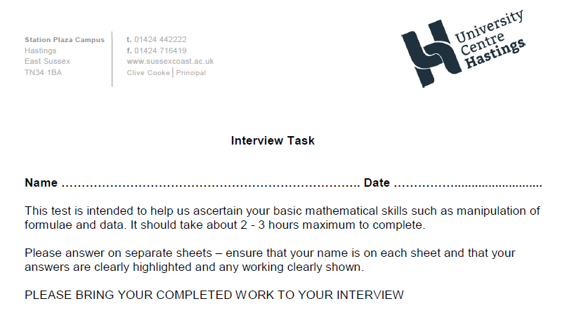

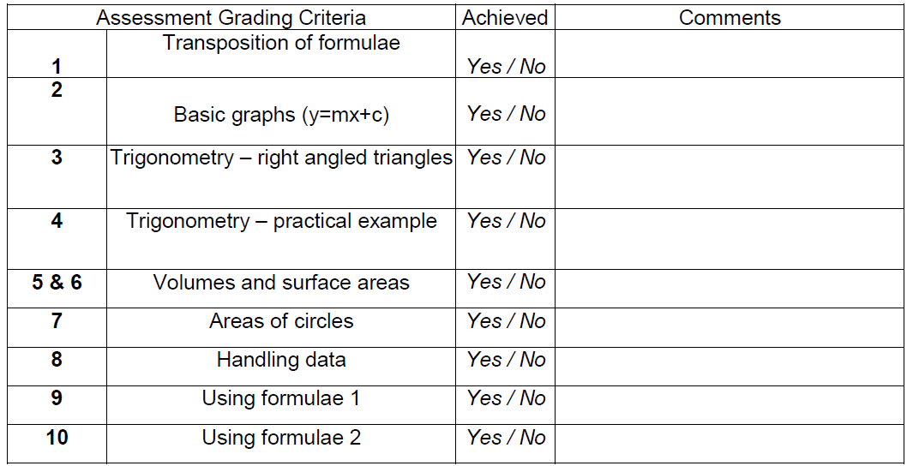

|  |  |  |  |
| --- | --- | --- | --- |
| 11 | Electronics | Yes/No |  |



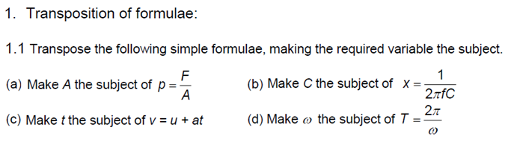

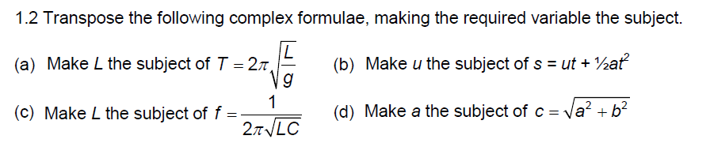

1.3 Simplify (a) d3 x d4)/d5 (b) 4p3 x 3p7

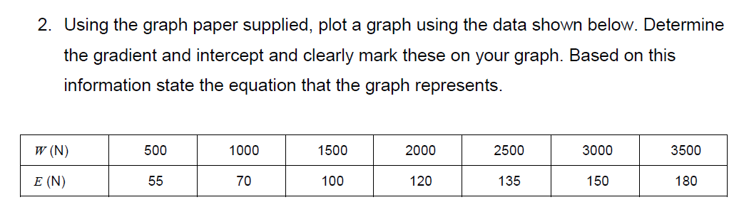



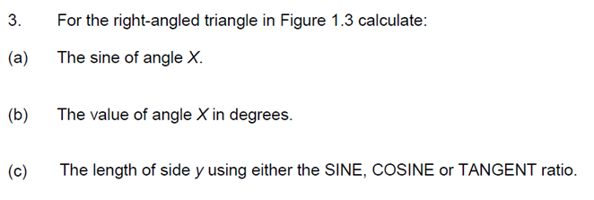

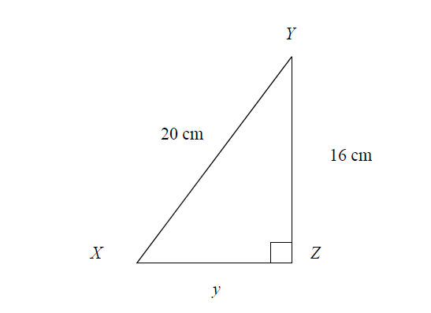

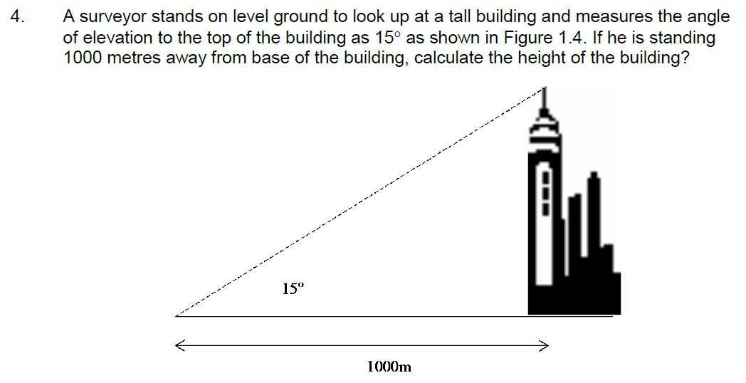

A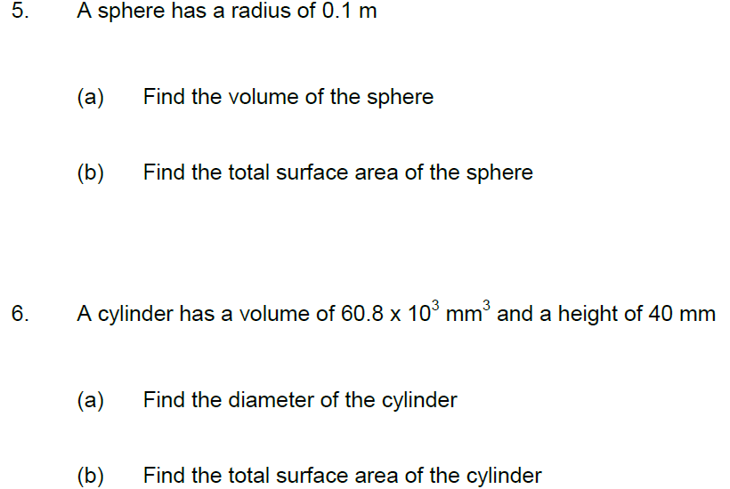

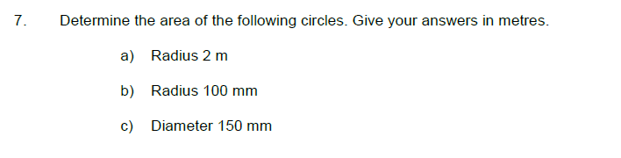

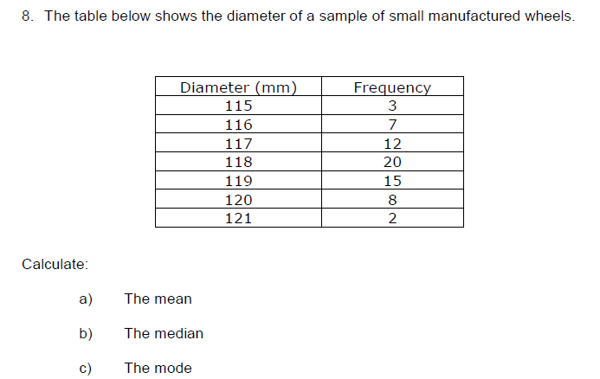

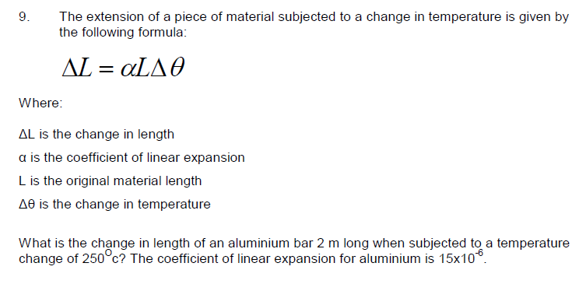

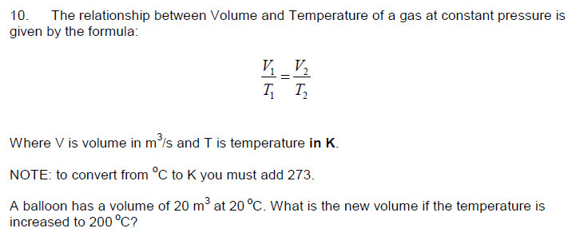

**ELECTRONICS APPLICANTS ADDITIONAL QUESTIONS**

**Show all formulae used and all workings**

11a

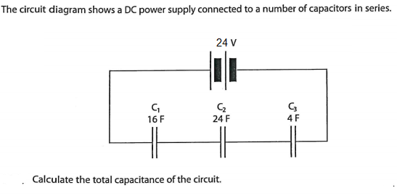

11b

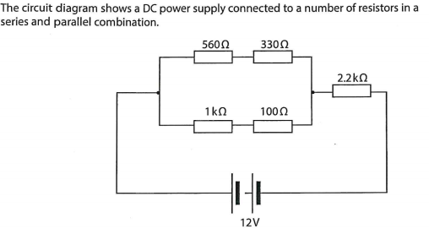

1. Calculate the Resistance in the parallel branch
2. Calculate the total Resistance in the Circuit
3. Calculate the current in the Circuit
4. Calculate the Power in the circuit